Fall 22 - HOMEWORK 1 – Due 9/24

1. Convert the following regular grammar into a Finite Automata

S X after starting from X the transition S -> `X`

1. x X | x Y x transtions, X moves to itself,| x transition to xY means machine is moving to a different state.

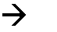

1. y Y | y Z y moves to itself then moves to Z state since it’s an NFA
2. zZ | z z moves to itself and then it will make a final state where the string will be accepted and end because z is a terminal .

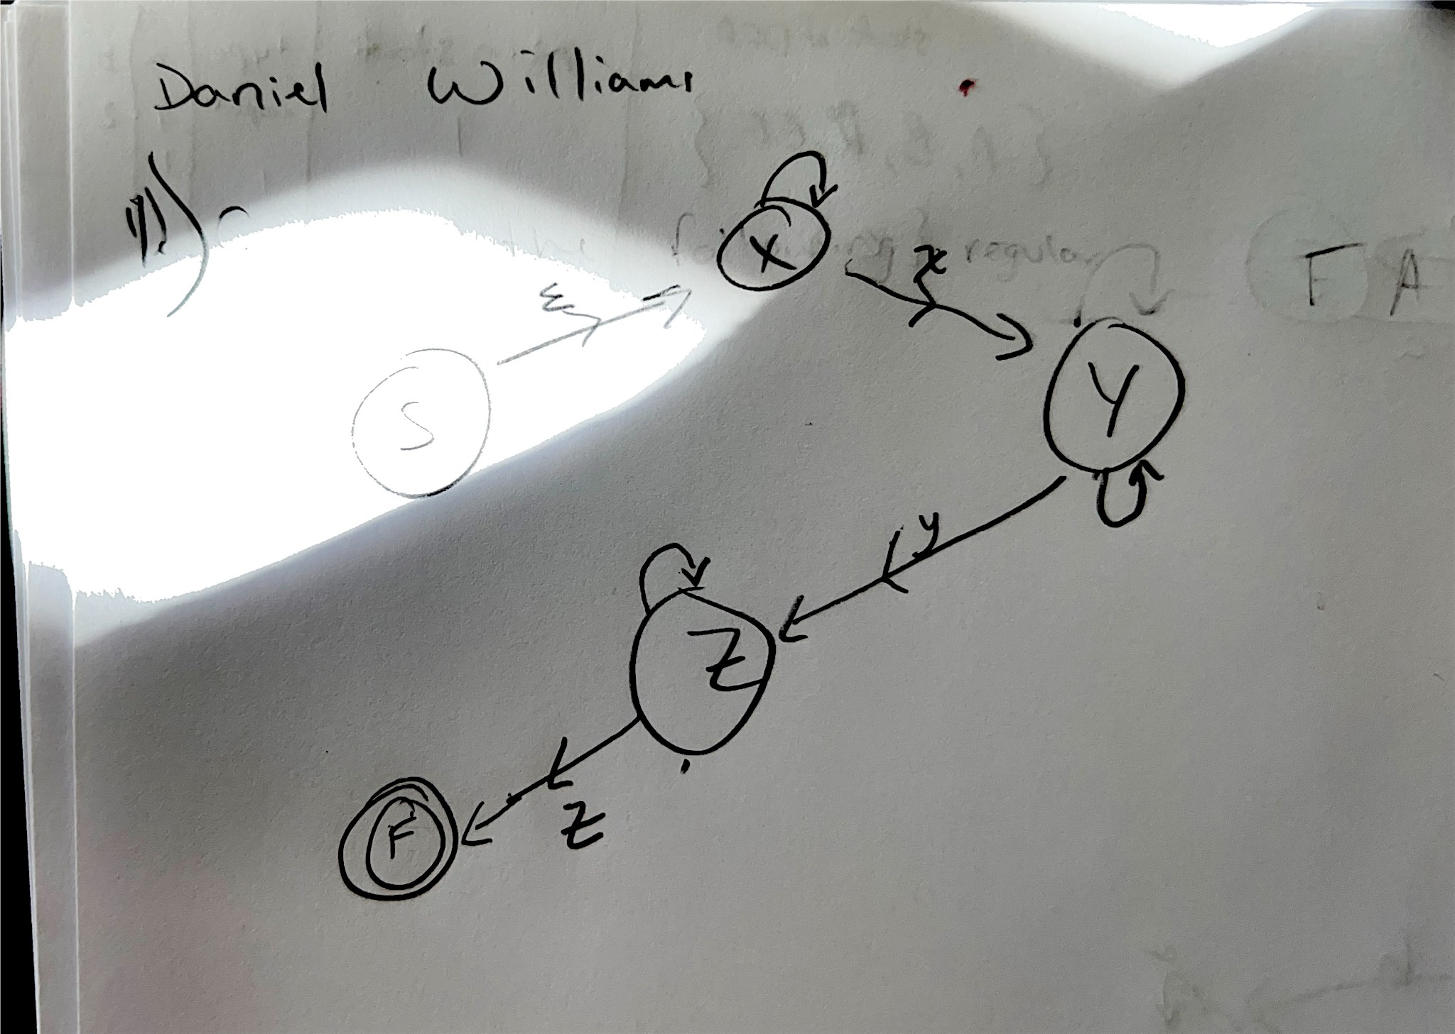

2.Convert the previous problem to a regular expression.

Regualar expression result = (x*xy*yz*z)

3.Write a grammar that generates an even number of X’s.

S 🡪 xxS|E

4.Convert problem 3 to a finite automata ((S)) 🡪 (A) and the x 🡪 for sucession and x 🡪 A to the final state of ((S)).

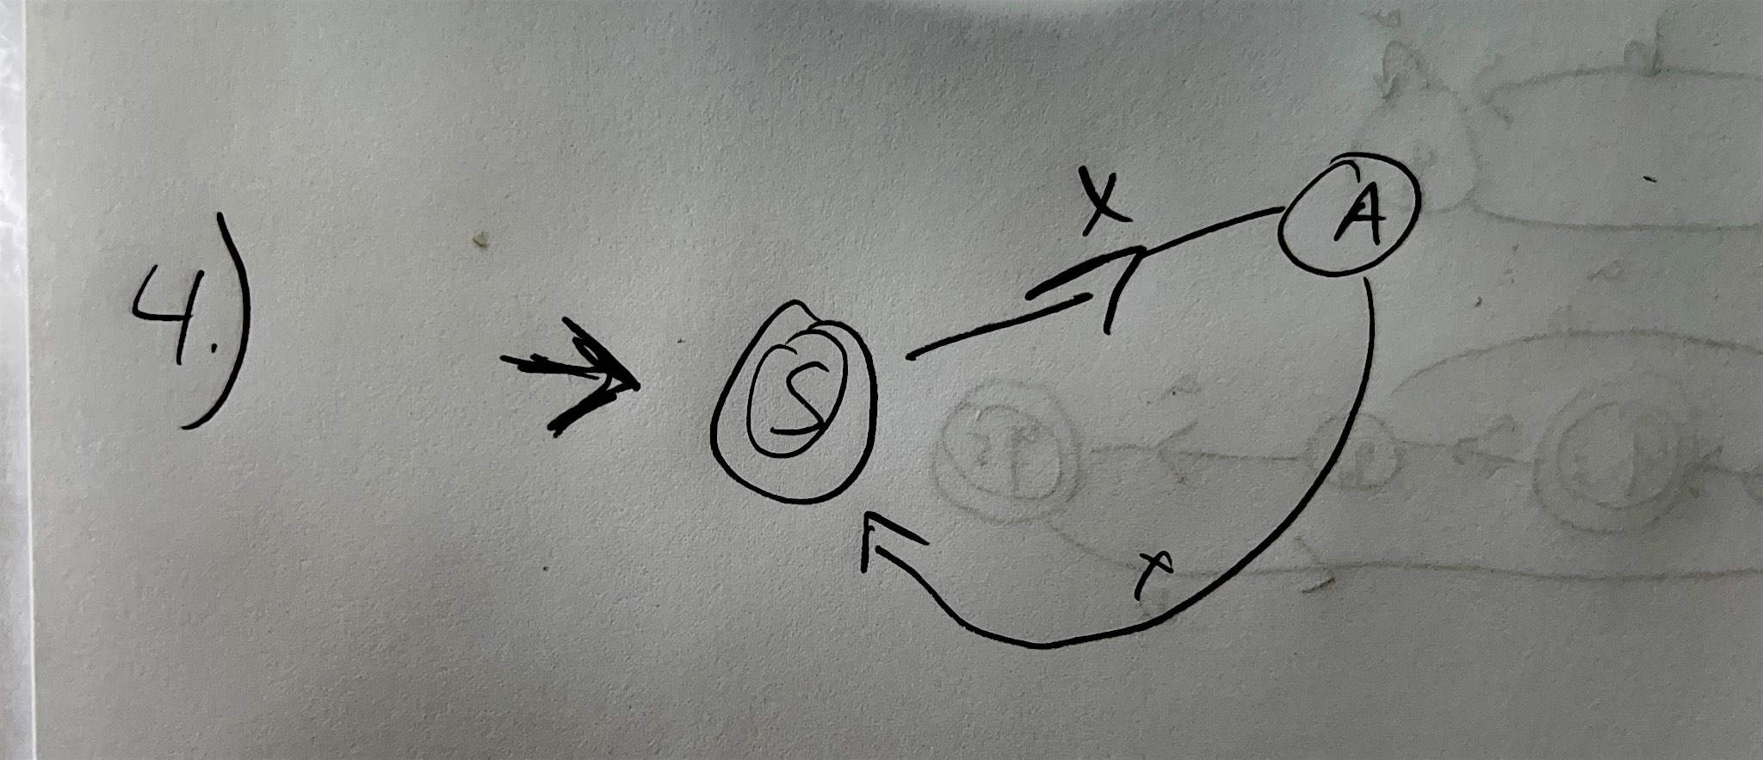

5.Convert problem 3 to a regular expression.

S🡪xxS|E , S🡪xxS, xxxxS, xxxxxxS xxxxxxxxS etc until it become all x’s of E and terminate a (xx)* which makes the regular expression (xx)*.

6.Give a nondeterministic finite automaton that accepts the language generated by the regular expression (a | ba | baaa)*

Is a Non DFA. Accept {Epsilon , a, ba, baa, aa,aba, baaa, aab}

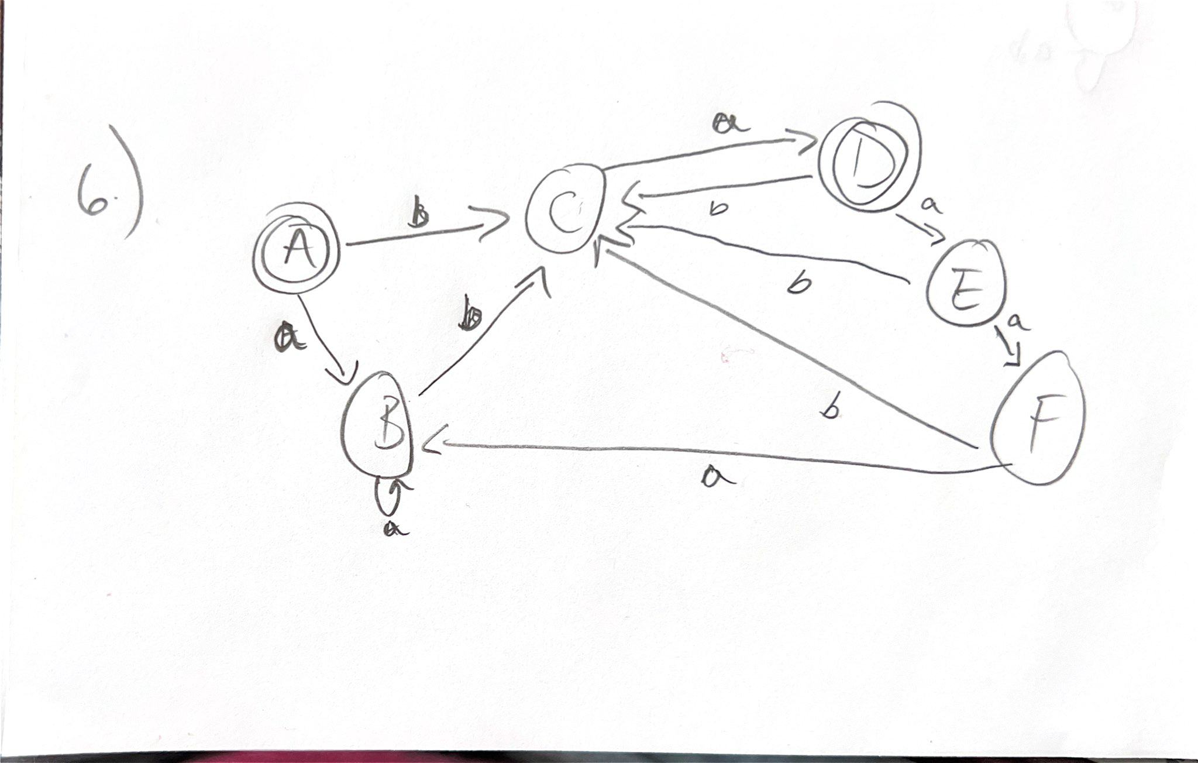

7.Convert the previous into a DFA

((1)) 🡪(b)🡪 (2) and returning ba to ((1)) and for ((1)) is recycled back into ((1)).

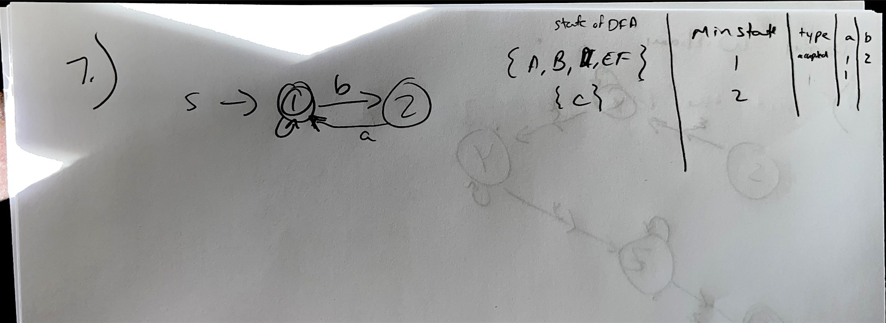

8.Convert the NFA below into a DFA. Where λ-transitions are the same as εtransitions.

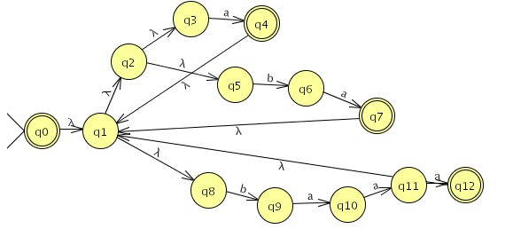

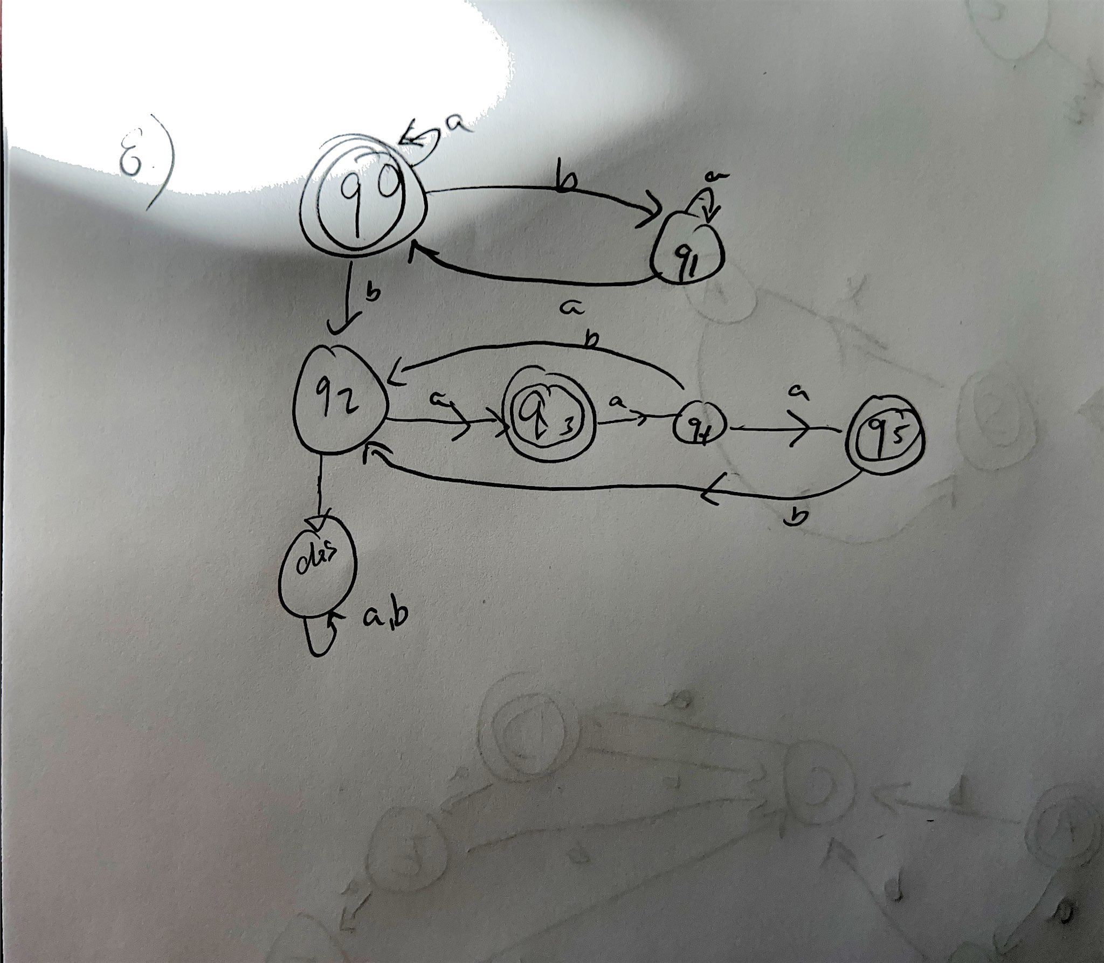

|  |  |  |
| --- | --- | --- |
| NFA State | DFA STATE | TyPE ab |
| {0,1,2,4,7,13} | A | acceptbc |
| {1,2,3,4,7,12,13} | B | Accept bc |
| {5,8} | C | D |
| {1,2,4,6,7,9,12,13} | D | Accept EC |
| {1,2,3,4,7,10,12, 13} | E | Accept FC |
| {1,2,3,4,7,11,12,13} | F | Accept BC |